Er RAJAT KALIA
(B.TECH IIT-Delhi)
PH. 9815439805
Er MANISH KALIA
B.TECH (Delhi COLLEGE OF ENGINEERING)
PH. 09990074601,9878146388

9DE

History of calculus is very old since 200 BC Bhaskara in 12th century develop a no. of ideas that led to development of Rolle's Theorem. He was also first to define notion of derivative as a limit.
Leibniz & Newton pulled these ideas further. Newton was first to apply calculus to general physics. These great scholar developed fundamental theorem of calculus.
Today, calculus is used in every branching of physical sciences, in computer science, in statistics and in engineeerings, in economics, business etc.
Derivative as rate of change:
If variable quantity y is function of t i.e. y = f(t), then small change in time y in y
Average rate of change =
when t 0, rate of change becomes instantaneous
i.e. 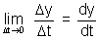
Illustration: If radius of circle increasing at uniform rate of 2 cm/s, find rate of increasing of area of circle, at instant when radius is 20 cm.
Ans: = 2 cm/s
Area of circle = r²
Differentiating w.r.t. to t,
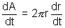
> = 2 x 20 x 2 = 80 cm²/s
Slopes of tangent & Normal:
Slope of tangent:
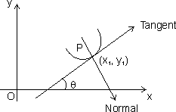
Let y = f(x) be cont. & P(x₁, y₁) be point on it.
Then 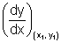is slope of tangent to curve y = f(x) at point P.
Note: (1) If tangent is 11 to x-axis, then
= 0
(2) If tangent is to x-axis, then
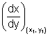= 0
Dumb Question: How = 0 when tangent is 11 to x-axis.
Ans: We know that slope of line = tan where 0 with x-axis in anticlockwise direction.
If tangent is 11 to x-axis
= 0 or tan = 0
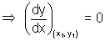
Slope of Normal: Normal to curve at P is line to tangent at P & passing through P(x₁, y₁)
Slope of normal at P = - 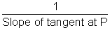
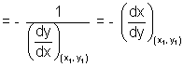
Note: (i) If normal is 11 to x-axis
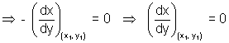
(ii) If normal is to x-axis
- = 0
Illustration: Find point on curve y = x³ - 3x at which tangent is 11 to x-axis.
Ans: Let the point be P(x₁, y₁) on curve y = x³ - 3x .................................... (i)
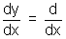 (x³ - 3x) = 3x² - 3
= 3x₁² - 3
But tangent is 11 to x-axis
= 0
3x₁² - 3 = 0 x₁ = ±1 ........................................ (ii)
Since P(x₁, y₁) lies on curve.
y₁ = x₁³ - 3x₁
x₁ = 1 where x₁ = - 1
y₁ = 1 - 3 = - 2 y₁ = - 1 + 3 = 2
Points are (1, - 2) & (- 1, 2)
Equations of tangent & Normals:
Eq. of tangent:
Slope of tangent at P(x₁, y₁) = tan =
Since it passes through P(x₁, y₁)
eq. of tangent is
(y - y₁) = (x - x₁)
Eq. of Normal:
Slope of Normal = -
Eq. of normal is
(y - y₁) = - (x - x₁)
Illustration: Find eq. of tangent & normal to curve 2y = 3 - x² at (1,1)
Ans: Eq. of given curve is 2y = 3 - x² ...................................... (i)
differentiating (i) w.r.t. x 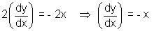
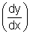_{(1, 1)} = - 1
eq. of tangent at (1, 1) is
y - 1 = - 1(x - 1) x + y = 2
& eq. of normal at (1,1) is
y - 1 = 1(x - 1) = y - x = 0
Angle of intersection of two curves:
It is angle b/w tangent s to the two curves at this point of intersection.
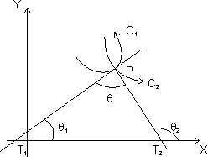
Let C₁ & C₂ be two curves of eq. is = f(x) & y = g(x) respectively.
Let is angle b/w two tangents of two curves & tangents PT₁ & PT₂ makes angle ₁ & ₂ respectively with x-axis.
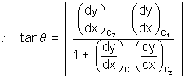

troduction
Dumb Question: How this derived ?
Ans: Let m₁ = tan ₁ = 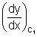
m₂ = tan ₂ = 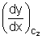
From fiq, = + ₁
= ₂ - ₁
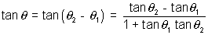
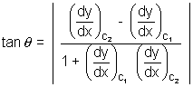
Orthogonal curves: If angle of intersection of two curves is right angle, two curves are c/d orthogonal curves.
If curves are orthogonal, =
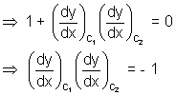
Illustration: Find angle of intersection of curves y = x² & y = 4 - x²
For intersection points of given curves,
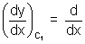(x²) = 2x
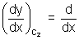(4 - x²) = - 2x
At x = - ,
= 2 x = 2 & = - 2
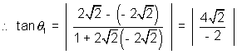
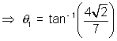
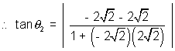
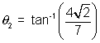
Both angles are equal.
Length of Tangent, Sub-Tangent, Normal & sub-Normal:
Length of Tangent: Length of segment PT of tangent b/w point of tangent & x-axis is c/d length of tangent.
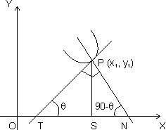
PT = 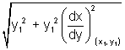
Subtangent: Projection of segment PT along x-axis i.e. St c/d subtangent.
Length of Normal: Length of segment PN intercapted b/w point on curve r x-axis.
PN =
Subnormal: Projection of segment PN along x-axis i.e. c/d subnormal.
SN = |y, 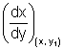
Dumb Question: How these relation derived ?
Ans: Since PT makes angle with x-axis, then
tan =
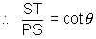
Subtangent = ST = PS cot
But PS = y₁ & cot = [see in fig.]
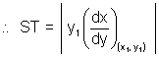
= cot(90 - ) PS tan
Subnormal = SN = 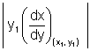
Length of tangent = PT = 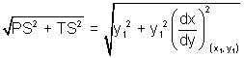
Length normal = PN = 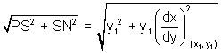
Illustration: Show that curve y = be^{x/a}. subnormal varies as square of ordinate ?
Ans:
[Dumb Question: What is ordinate ?
Ans: y-axis component is c/d ordi i.e. in P(x₁, y₁)y₁ is ordinate of point P.
y = be^{x/a} ............................................... (i)
differentiating curve y = be^{x/a} w.r.t. x.
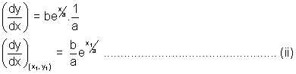
& Let P(x₁, y₁) lie on curve
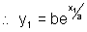
Length of subnormal = 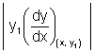
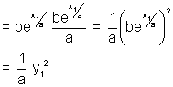
So, subnormal varies as square of ordinate.

Rolle's Theorem:
Statement: Let f be real valued function defined on closed interval [a, b] such that,
(i) f(x) is continuous in closed interval [a, b].
(ii) f(x) is differentiable in open interval (a, b).
(iii) f(a) = f(b)
Then there is at least one value of C of x in (a, b) for which f'(c) = 0
Proof: Case I: f(x) is constant function in interval [a, b] then f'(x) = 0 for all x [a, b]
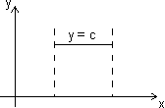
Hence, follows Rolle's theorem, we can say that f'(c) = 0 where a < c < b.
Case II: f(x) is not constant in interval [a, b] & sionce f(a) = f(b)
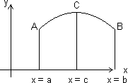
Let f(x) increases for x > a.
Since f(a) = f(b), so, function must increase to some value x = c & decreasing upto x = b.
At x = c function has maximum value.
Let h be small quantity, then,
f(c + h) - f(c) < 0 & f(c - h) - f(c) < 0
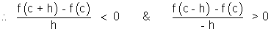
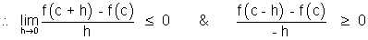
But if 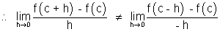
Then Rolle's theorem cannot applicable b/c. f(x) is not differentiable at x = c
Only possible way for Rolle's theorem, when
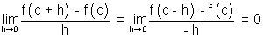
f'(c) = 0 where a < c < b
Note: (i) Polynomial function is everywhere cont. & differentiable.
(ii) Exponential function, sine & cosine function are everywhere cont. & differentiable.
(iii) Logarithmic function is cont. & differentiable in its domain.
(iv) tanx is not cont. & differentiable at x = ± , ± , ...............
(v) |x| is not differentiable at x = 0.
Illustration: Verify Rolle's theorem for function f(x) = x³ - 3x² + 2x in interval [0, 2].
Ans: (a) f(x) is polynomial so, it is cont. & differentiable everywhere.
(b) f'(x) = 3x² - 6x + 2 clearly exista for all x (0,2)
(c) f(0) = 0, f(2) = 2³ - 3(2)² + 2(2) = 0
f(0) = f(2)
So, All conditions of Rolle's theorem are satisfied.
So, there exist some c (0,2) such that f'(c) = 0
f'(c) = 3c² - 6c + 2 = 0 c = 1 ±
Lagrange's Mean Value Theorem:
Statement:
(i) f(x) is cont. in closed interval [a, b].
(ii) is differentiable in open interval (a, b)
Then there is at least one value c (a, b) such that
f'(c) = 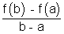
Geometrical interpretation:
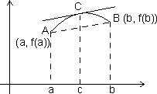
Let A, B be points on curve y = f(x) corresponding to x = a & x = b, so that
A = [a, f(a)] & B = [b, f(b)]
Slope of chord AB =
But slope of chord AB = f'(c), the slope of tangent to curve at x = c.
Accordin to LMVT, if a curve has tangent at each of its points then there is a point 'c' on this curve in between A & B, the tangent at which is paralled to chord AB.
Illustration: Find c of LMVT for which f(x) = in [1, 5].
Ans: (1) f(x) has definite & unique value of each x [1, 5]
So, every point in interval [1, 5] the value of f(x) is equal to limit of f(x).
f(x) is cont. in [1, 5]
(2) f'(x) = - 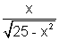exists for all x [1, 5]
f(x) is differentiable in (1, b)
So, there must br some c such that
f'(c) = 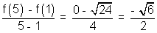
But f'(c) = 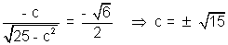
Application of derivative in determining the nature of roots of cubic polynomial:
Let f(x) = x³ + ax² + bx + c be given cubic polynomial.
f(x) = 0
f'(x) = 3x² + 2ax + b ....................................................... (i)
Let D = 4a² - 12b = 4(a² - 3b) be discriminate of eq. f'(x) = 0
Case I: If D < 0 f'(x) > 0 v x R
f(x) = - and
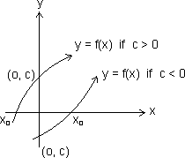
from fig. graph of y = f(x) cut x-axis only once. So, we have only real root (say x₀)
x₀ > 0 if c < 0 & x₀ < 0 if c > 0
Case II: If D > 0, f'(x) = 0
have two real roots.
f'(x) = 3(x - x₁)(x - x₂)
f'(x) < 0, x (x₁, x₂)
f'(x) > 0, x (- , x₁) U (x₂, )
f(x) would increase in (-, x₁) & (x₂, ) and would decrese in (x₁, x₂)
x = x₁ would be point of local maxima & x = x₂ would be point of local minima.
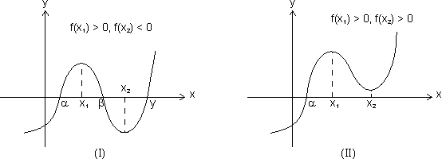
3 distict roots x = , , One real root x = & two imaginary root
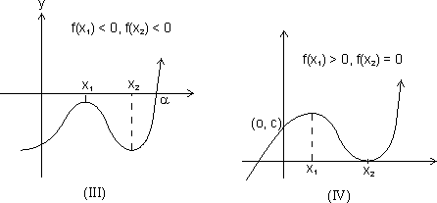
One real root x = 9 & Three roots x = , n₂, x₂
two imaginary roots. (x₂ is repeated root)
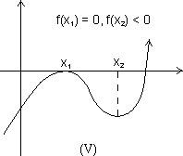

Threen real roots x = n₁, x₂,
(x₁ is repeated roots)
Results:
(a) From I graph, f(x₁) > 0, f(x₂) < 0
f(x₁) f(x₂) < 0, f(x) = 0 would have 3 real & distinct roots.
(b) Fromn II & III graph f(x₁) f(x₂) > 0, f(x) = 0 have one real & two imaginary roots.
(c) f(x₁ f(x₂) = 0, f(x) = 0 have 3 real roots but of root would be repeated.
Case III: D = 0, f'(x) = 3(x - x₁)⁰ where x₁ is root of f'(x).
f(x) = (x - x₁)³ + K
Then, f(x) = 0, has three real roots if K = 0
f(x) = 0 has one real root if K 0
Illustration: Find values of a so that x³ - 3x + a = 0 has three real & distinct roots.
Ans: Let f(x) = 3x³ - 3x + a
f'(x) = 3x² - 3 = 3(x - 1)(x + 1)
x₁ = 1, x₂ = - 1
f(x₁) = f(1) = a - 2
f(x₂) = f(- 1) = a + 2
Since roots would be real & distinct if
f(1) f(- 1) < 0 (a - 2)(a + 2) < 0
- 2 < a < 2

Increasing function:
(a) Strictly increasing function:
A function f(x) is c/d strictly increasing function in its domain if x₁ < x₂
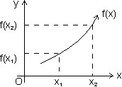
For strictly increasing function f'(x) > 0 v x domain
Dumb Question: How f'(x) > 0n v x domain for strictly increasin function.
Ans: As x₁ < x₂
f(x₁) < f(x₂)
So, f(x) < f(n + h)
f'(x) = 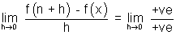
f'(x) > 0
Types of strictly increasing function:
(1) Concave up: When f'(x) > 0 & f"(x) > 0 v x domain
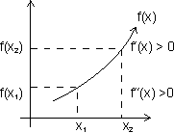
(2) Concave down: f'(x) > 0 & f"(x) < 0 v x domain
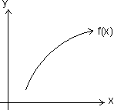
(3) When f'(x) > 0 & f"(x) = 0 v x domain
f'(x)> 0 & f"(x) = 0
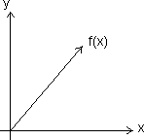
Increasing function:
A function f(x) is said to be non decreasing if for x₁ < x₂
Laet us see in fig.
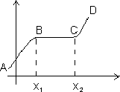
For portion ABCD, x₁ < x₂
f(x₁) < f(x₂)
for BC, x₁ < x₂
f(x₁) = f(x₂)
Dumb Question: What is diff. b/w strictly increasing & increasing function ?
Ans: Strictly function for x₁ < x₂, f(x₂) is always greater than f(x₁) but in increasing function for x₁ < x₂, f(x₂ may be greater or equal to f(x₁).
Decreasing functions:
(a) Strictly decreasing function:
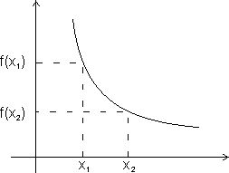
A function f(x) ic c/d strictly decreasimg in its domain if x₁ < x₂
f(x₁) > f(x₂)
For strictly decreasing function.
f'(x) < 0
Dumb Question: How f'(x) < 0 for strictly decreasing ?
Ans: As x₁ < x₂ f(x₁) > f(x₂)
So, f(x + h) < f(x)
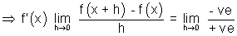
f'(x) < 0
Types of strictly decreasing function:
(i) Concave up:
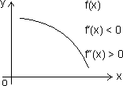
When f'(x) < 0
f''(x) > 0 v x domain
(ii) Concave down:
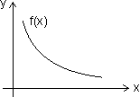
When f'(x) < 0 & f''(x) < 0 v x domain
(iii)
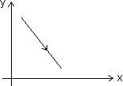
When f'(x) < 0 & f'(x) = 0 v x domain
(5) Non-increasing function:
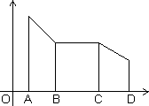
A function f(x) is c/d non-increasing if for x₁ < x₂
for x₁ < x₂
f(x₁) f(x₂)
For AB & CD, x₁ < x₂
f(x₁ > f(x₂)
Bc, x₁ < x₂
f(x₁ = f(x₂)
Illustration: Find interval in which f(x) = x³ - 3x² - 9x + 20 is strictly increasing or decreasing.
Ans: f(x) = x³ - 3x² - 9x + 20
f'(x) = 3x² - 6x - 9
f'(x) = 3(x - 3)(x + 1)
For strictly increasing
f'(x) > 0
3(x - 3)(x + 1) > 0 (x - 3)(x + 1) > 0
(x + 1) < 0 or (x - 3) > 0
x < - 1 or x > 3
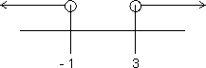
x (- , - 1) U (3, )
For strictly decreasing
f'(x) < 0
(x + 1)(x - 3) < 0
x (- 1, 3)
Properties of Monotonic function:
(1) If f(x) is strictly increasing function on [a, b]
{ f'(x) exists & f'(x) is also strictly increasing on [a, b].
(2) If f(x) & g(x) are also two continous & differentiable functions & fog(x) & gof(x) exists . then,
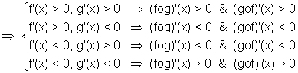
In other words
(i) If f(x) & g(x) are both strictly increasing or strictly decreasing.
(fog)(x) & (gof)(x) both are strictly inctreasing.
(ii) If amongst two functions f(x) & g(x), one is strictly increasing other is strictly decreasing.
(fog)(x) & (gof)(x) both are strictly decreasing.
Illustration: Let Ø(x) = sin(cosx) then check it whethe5r increasing ordecreasing in [0, ].
Ans: Ø(x) will be increasing if Ø'(x) > 0
Ø(x) = sin(cosx)
Ø'(x) = cos(cosx).(- sinx)
So, it is clearly decreasing for x [0, ] as Ø'(x) 0
Other method: f(x) = sinx & I(x) = cosx are increasing & decreasing in [0, ]
fog(x) = Ø(x) = sin(cosx) is decreasing.
Critical Points:
It is collection of points for which,
(i) f(x) does not exists.
(ii) f'(x) does not exists.
(iii) f'(x) = 0
All values of x obtained from above conditions are c/d critical points.
Illustration: Find critical points for f(x) = (x - 2)^{2/3}(2x + 1)
Ans: f(x) = (x - 2)^{2/3}(2x + 1)
f'(x) = 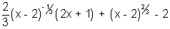
f'(x) = 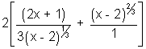
Clearly f'(x) doesnot defined at x = 2 so, x = 2 is critical point.
Dumb Question: Why f'(x) is not defined at x = 2 ?
Ans: Putting x = 2, f'(x) = which is not defined.
Another critical point
f'(x) = 0
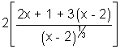= 0 x = 1
So, x = 1 & x = 2 are two critical points of f(x)
Maxima & Minima:
Maxima: A function f(x) is said have maxima at x = a if f(a) f(a + h) where h 0 (very small & a lies in its domain.
Minima: A function f(x) is said to have minima at x = b if f(b) f(b + b) & f(b) f(b - b) where h 0 (very small)
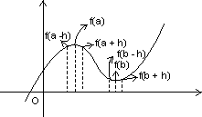
Methods for finding extremum of continuone functions:
(a) First derivative test:
(i) When f(x) attains maximum at x = a:
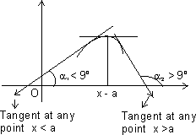
From graph,
For x < a, ₁ < 90⁰ tan₁ > 0 or increasing for x < a
For x = a, tan = 0 or neither increasing nor decreasing for x = a.
For x > a, ₂ > 90⁰ tan₂ < 0 or decreasing for x > a
So,
f(x) is maximum at x =a
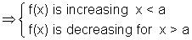
(ii) When f(x) attains minimum at x = b:
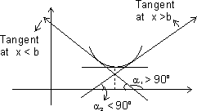
From graph,
For x < b, ₁ > 90⁰ tan₁ < 0 or decreasing when x - < b
For x = b, tan = 0 or neither increasing nor decreasing for x = b
For x > b, ₂ < 90⁰ tan₂ > 0 or increasing when x > b
So,
f(x) is minimum at x = b
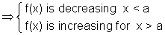
Illustration: Let f(x) = x³ - 3x² + 6, find point at which f(x) have local maximum & local minimum.
Ans: f(x) = x³ - 3x² + 6
f'(x) = 3x² - 6x
Critical points are if f'(x) = 0
3x² - 6x = 0 x² - 2x = 0
x = 0, 2
At x = 0, f'(x) change sign from + ve to - ve & f'(x) changes sign from - ve to + ve at x = 2.
So, at x = 0, function has local maxima 7 at x = 2 it has local minima.
Second Derivative Test:
(1) First we find root of f'(x) = 0.
Let x = a is one roots of f'(x) = 0
(2) Now find f''(x) at x = a
(i) If f''(a) = -ve, then f(x) is max. at x = a.
(ii) If f''(a) = +ve, then f(x) is min. at x = a
(iii) If f''(a) = 0
Then find F'''(x) at x = 0
If f'''(a) = 0 then f(x) has neither maximum nor minimum at x = a.
But if f'''(a) = + ve, then find f'^{v}(a),
(a) If f'^{v} = + ve, then f(x) is min. at x = a.
(b) If f'^{v}(a) = - ve, then f(x) is max. at x = a.

Dumb Question: How y = |x² - 3| = - (x² - 3) for neighbour hood of x = .
Ans: y = |x² - 3| since |x² - 3| is + ve quantity.
If we put x = , x² - 3 = - 1 but is + ve quantity so, we put - ve to make it + ve.
So, y = |x² - 3| = - (x² - 3)
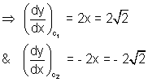
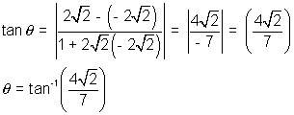
Q.6. If ax² + bx + c = 0, a,b,c R. Find condition that this eq. would have at least one root in (0, 1).
Ans: Let f'(x) = ax² + bx + c
Integrating both sides,
f(x) = 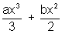+ cx + d ......................................... (i)
f(0) = d & f(1) = 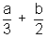+ c + d
Since, Rolle's theorem is applicable.
[Dumb Question: Why Rolle's theorem is applicable ?
Ans: Rolle's theorem is applicable b/c f(x) is polynomial function which is continuous & differentiable everywhare.]
f(0) = f(1)
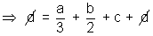
2a + 3b + 6c = 0
required condition.
Q.7. Let f(x) & g(x) be differentiable for 0 x 2 such that f(0) = 2, g(0) = 1 & f(2) = 8. Let there exists a real no. c in [0, 2] such that f'(c) = 3g'(c) find value of g(2).
Ans: As f(x) & g(x) are cobt. & differentiable in ... then there exists atleast one value 'c' such that
f'(c) = 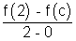
g'(c) = 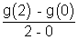
But 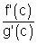= 3
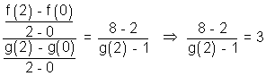
g(2) = 3
Q.8. f(x) is a polynomial of degree 4 with real coeff. such that f(x) = 0 is satisfied by x = 1, 2, 3 only, them and f'(1) f'(2) f'(3) ?
Ans: f(x) = 0 has only roots 1, 2, 3 only
But it is degree 4 eq.
Any one of 1, 2, or 3 is 4 repeated root of f(x) = 0
f'(1) or f'(2) or f'(3) any one of them must be zero.
f'(1) f'(2) f'(3) = 0
Q.9. Find interval for which f(x) = x - cosx is increasing or dectreasing.
Ans: f(x) = x - cosx
Differentiating w.r.t. x
f'(x) = 1 - sinx
we know
-1 sinx | for all x R
.... sin 0 for x v R.
Q.10. If a < 0, & f(x) = e^{ax} + e^{-ax} is monotonically decreasing. Find interval to which x belongs.
Ans: Given a < o &
f(x) = e^{ax} + e^{-ax} is decreasing
f'(x) < 0 ae^{ax} - ae^{-xx} < 0
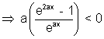
But a < 0
(e^{2ax} - 1) > 0 e^{2ax} > 1
2ax > 0 ax > 1
x < 0 as a < 0
Medium Type:
Q.1. Find values of 'k' for which point min. of function f(x) = 1 + k²x - x³ satisfy inequality 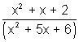< 0.
Ans: 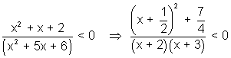
Since 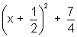it always +ve
(x + 2)(x + 3) < 0
- 3 < x < - 2 ........................................................ (i)
f(x) = 1 + k²x - x³
f'(x) = k² - 3x²
f''(x) = - 6x
For max/min, f(x) = 0
x = ±
Let x₁ = & x₂ = -
f''(x₁) < 0 & f''(x₂) > 0
f(x) is max. at x = x₁ & min. at x = x₂
But x₂ is min. which lies b/w
- 3 < x₂ < - 2 (from relation (i))
- 3 < - < - 2
3 > |k| > 2
k (- 3, - 2) U (2, 3)
Q.2. If f(x) = , x > 0 determine bigger of two no. & ^{e}.
Ans. y = f(x) = , x > 0
Taking log on both sides
ln y = ln x
Differentiating both side
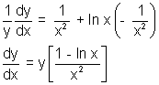
f'(x) = [1 - ln x]
Let f'(x) = 0
log x = 0 or x = e
f''(x) = 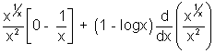
f''(e) = 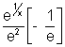+ 0
f''(e) < 0
f(x) has maxima at x = e
f(e) > f() for all x > 0
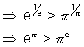
Q.3. If f(x) = ax³ + bx² + cx + d where a, b, c, d are real no.s & 3b² < c², is an increasing cubic function & g(x) = af'(x) + bf''(x) + c², then prove that 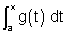is an increasing function.
Ans: f(x) = ax³ + bx² + cx + d
f'(x) = 3ax² + 2bx + c
Since f(x) is increasing
f'(x) > 0 3ax² + 2bx + c > 0
3a > 0 & D < 0
3a > 0 & b² - 3ac < 0
a > 0 & b² < 3ac ........................................ (i)
g(x) = af'(x) + bf''(x) + c²
g(x) = 3a²x² + 2abx + ac + 6abx + 2b² + c²
g(x) = 3a²x² + 8abx + (2b² + c² + ac)
D = 64a²b² - 4.3a²(2b² + c² + ac)
= 4a²(10b² - 3c² - 3ac)
Since 3ac > b² from (i)
- 3ac < - b²
4a²(10b² - 3c² - 3ac) < 4a²(10b² - 3c² - b²)
= 4a²(9b² - 3c²)
Since 3b² < c²
= 12a²(3b² - c²) = -ve
D < 0
g(x) > 0 v x R
is increasing function.

Q.4. If at each point of curve y = x³ - ax² + x + 1 tangent is inclined at acute angle with +ve direction of x-axis. Find interval in which a lies.
Ans: y = x³ - ax² + x + 1
Sine tangent is inclined at an acute angle with the direction of x-axis.
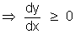
= 3x² - 2ax + 1 0 for all x R
But if ax² + bx + c 0 for x R
a > 0 & D 0
D = (2a)² - 4(3)(11)
= 4(a² - 3)
D 0
(a² - 3) 0 (a - )(a + ) 0
- a
Dumb Question: How 0 if angle is acute.
Ans: Since = tan & if is lessthan . So, tan 0. So, 0
Q.5. If f(x) = log_{e}x & g(x) = x² & c (4, 5), then find value of c log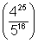
Ans: log(4²⁵) - log5¹⁶
25 log4 - 16 log5
Since domain is [4, 5]
So, let
Ø(x) = x² (log4) - 16 logx i9s cont. [45, 5] & differentiable on (4, 5)
By LMUT,
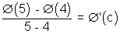, c (4, 5)
Ø(5) - Ø(4) = log
But, Ø'(c) = (c² log4 - 8) ........................................ (i)
also Ø'(c) = 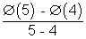........................................... (ii)
By (i) & (ii)
(c² log_{e}4 - 8) = log_{e}
c log = 2(c² log4 - 8)
Hard Type:
Q.1. Let S be square of unit area. Consider aany quadrilateral which has one vertex on each side of s. If a, b, c, & d denote lengths of side of quadrilateral, prove that
2 a² + b² + c² + d² 4
Ans:
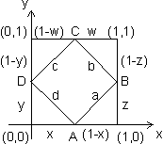
Let S be square of unit area & ABCD be quadrilateral of sides a, b, c & d
a² = (1 - x)² + z²
b² = w² + (1 - z)²
c² = (1 - w)² + (1 - y)²
d² = x² + y²
a² + b² + c² + d² = {x² + (1 - x)²} + {y² + (1 - y)²} + {z² + (1 - z)²}
+ {w² + (1 - w)²}
where 0 x, y, z, w 1
Let f(x) = x² + (1 - x)², 0 x 1
Then f'(x) = 2x - 2(1 - x)
f'(x) = 0 for min/max.
4x - 2 = 0 x =
Again f''(x) = 4 > 0 when x =
f(x) is min. at x = & m,ax. at x = 1
a² + b² + c² + d² = 4{x² + (1 - x)²}
Max. value of x² + (1 - x)² = 1² + (1 - 1)² = 1
Min. value of x² + (1 - x)² = 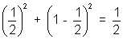
2 a² + b² + c² + d² 4
Q.2. Let a + b = 4 & a < 2 & let g(x) be differentiable function. If > 0 v x prove that 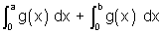increases as (b - a) increases.
Ans: Let (b - a) = t & since a + b = 4
a = 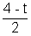 & b = 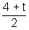 & t > 0
[Dumb Question: Why t = b - a > 0 ?
Ans: Since a < 2 &n & a + b = 4. So, b > 2
b - a > 0 or t > 0]
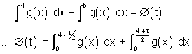
Ø(t) = 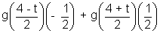 [By Leibniz rule]
[Dumb Question: What is Leibniz rule ?
Ans: Ø(t) = 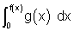]
Ø'(t) = g(f(x)) f'(x)
Since g(x) is increasing
x₂ > x₁ g(x₂) > g(x₁)
Now, > & g(x) is increasing
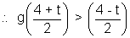
Ø'(t) = 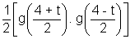> 0
Ø'(t) > 0
Ø'(t) is increases as t increases.
Q.3. Tangent represented by graph of function y = ... at the point with absciss a x = 1 from an angle & at point x = 2 an angle of & at the point x an angle of . Find value of 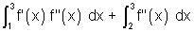.
Ans: Given
at x = 1, = tan =
at x = 1, f'(1) = tan =
at x = 2 f'(2) = tan =
at x = 3 f'(3) = tan = 1
Then,
Let f'(x) = t
f''(x) dx = dt
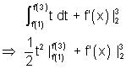
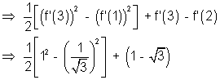
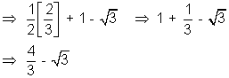

Key Words:
* Derivative.
* TAngent.
* Normal.
* Orthogonal Curves.
* Sub Tangent.
* Sub Normal.
* Rolle's Theorem.
* Layrange's Mean Value Theorem.
* Maxima.
* Minima.
* Monotonicity.

